**D.Y. PATIL COLLEGE OF ENGINEERING & TECHNOLOGY,**

**KASABA BAWADA, KOLHAPUR**

**DEPARTMENT OF COMPUTER SCIENCE AND ENGINEERING**

**(2021-22)**

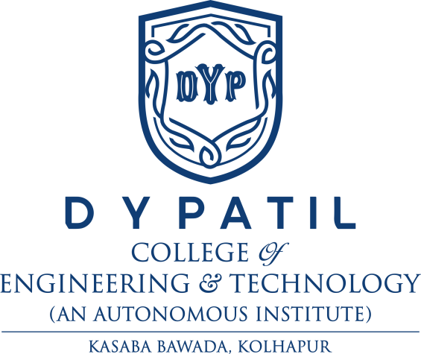

**A**

**Report on**

**Project - I**

“**C-Cure**”

**Submitted by:**

**Roll No.** **Name**

1 Mr. Anuj Gangane

2 Mr. Aditya Deshmukh

3 Mr. Santosh Mane

**Under the guidance of**

Prof S.G. Shete

**Class: SY(CSE) Div: B Batch: S2**

**DEPARTMENT OF COMPUTER SCIENCE AND ENGINEERING,**

**KOLHAPUR**

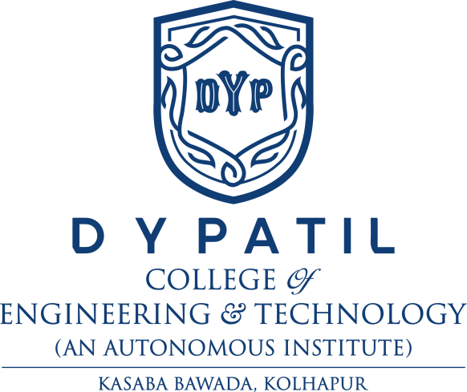

**CERTIFICATE**

This is to certify that the following members have satisfactorily completed the Project - I work entitled **“C-Cure”** at SY (CSE) semester-IV as prescribed in the syllabus of DYPCET Autonomy for the academic year 2021-22.

**Name**  **Exam seat no.**

1. Anuj Gangane

2. Aditya Deshmukh

3. Santosh Mane

**Date:**

**Place:** Kolhapur

**-----------------** **Prof. Dr. G. A. Patil**

(Project Guide) **(**HOD)

**--------------------** **Prof. Dr. S. D. Chede**

(Project Coordinator) (Principal)

**External Examiner**

**ACKNOWLEDGEMENT**

(Write in your own words, something about those who help you for Project- I development directly or indirectly)

**Date:**

**Place:** Kolhapur

**Name of Student**   **Sign**

1. Anuj Gangane

2. Aditya Deshmukh

3. Santosh Mane